Model Summary

Model: "sequential"
_________________________________________________________________
Layer (type) Output Shape Param #
=================================================================
conv2d (Conv2D) (None, 32, 32, 32) 896
_________________________________________________________________
activation (Activation) (None, 32, 32, 32) 0
_________________________________________________________________
batch_normalization (BatchNo (None, 32, 32, 32) 128
_________________________________________________________________
conv2d_1 (Conv2D) (None, 32, 32, 32) 9248
_________________________________________________________________
activation_1 (Activation) (None, 32, 32, 32) 0
_________________________________________________________________
batch_normalization_1 (Batch (None, 32, 32, 32) 128
_________________________________________________________________
max_pooling2d (MaxPooling2D) (None, 16, 16, 32) 0
_________________________________________________________________
dropout (Dropout) (None, 16, 16, 32) 0
_________________________________________________________________
conv2d_2 (Conv2D) (None, 16, 16, 64) 18496
_________________________________________________________________
activation_2 (Activation) (None, 16, 16, 64) 0
_________________________________________________________________
batch_normalization_2 (Batch (None, 16, 16, 64) 256
_________________________________________________________________
conv2d_3 (Conv2D) (None, 16, 16, 64) 36928
_________________________________________________________________
activation_3 (Activation) (None, 16, 16, 64) 0
_________________________________________________________________
batch_normalization_3 (Batch (None, 16, 16, 64) 256
_________________________________________________________________
max_pooling2d_1 (MaxPooling2 (None, 8, 8, 64) 0
_________________________________________________________________
dropout_1 (Dropout) (None, 8, 8, 64) 0
_________________________________________________________________
conv2d_4 (Conv2D) (None, 8, 8, 128) 73856
_________________________________________________________________
activation_4 (Activation) (None, 8, 8, 128) 0
_________________________________________________________________
batch_normalization_4 (Batch (None, 8, 8, 128) 512
_________________________________________________________________
conv2d_5 (Conv2D) (None, 8, 8, 128) 147584
_________________________________________________________________
activation_5 (Activation) (None, 8, 8, 128) 0
_________________________________________________________________
batch_normalization_5 (Batch (None, 8, 8, 128) 512
_________________________________________________________________
max_pooling2d_2 (MaxPooling2 (None, 4, 4, 128) 0
_________________________________________________________________
dropout_2 (Dropout) (None, 4, 4, 128) 0
_________________________________________________________________
flatten (Flatten) (None, 2048) 0
_________________________________________________________________
dense (Dense) (None, 10) 20490
=================================================================
Total params: 309,290
Trainable params: 308,394
Non-trainable params: 896
_________________________________________________________________

Model Results

79/79 [==============================] - 3s 26ms/step - loss: 0.4667 - accuracy: 0.8781

Test result: 87.810 loss: 0.467

Model Image (part 1 – Full image in model_arch.png)

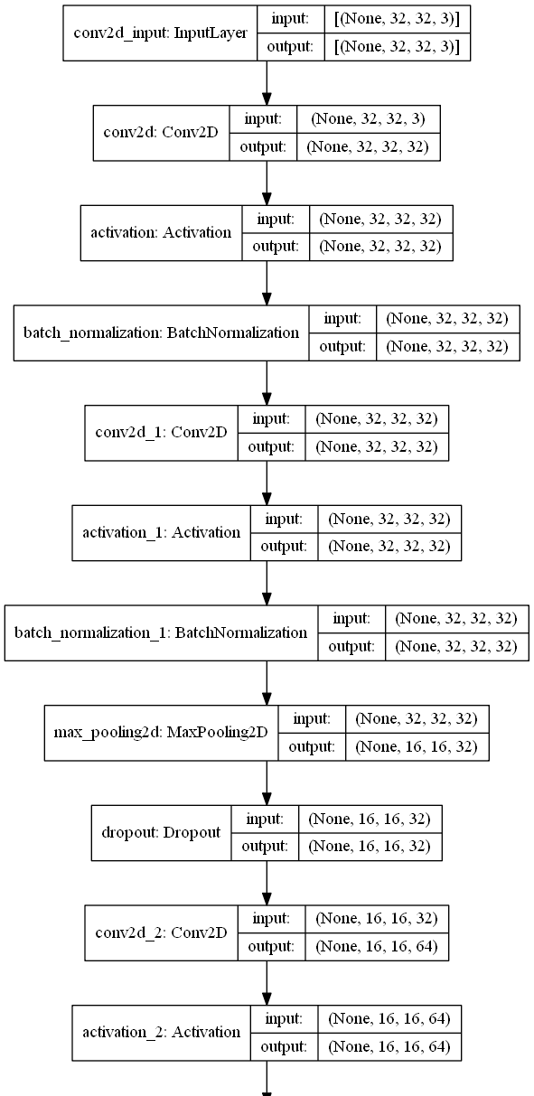
Model Image (part 2 – Full image in model_arch.png)

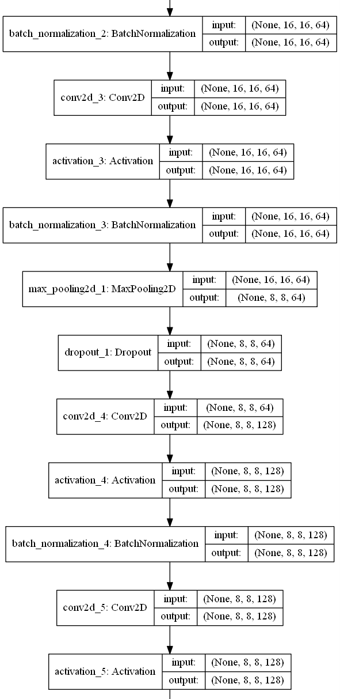
Model Image (part 3 – Full image in model_arch.png)

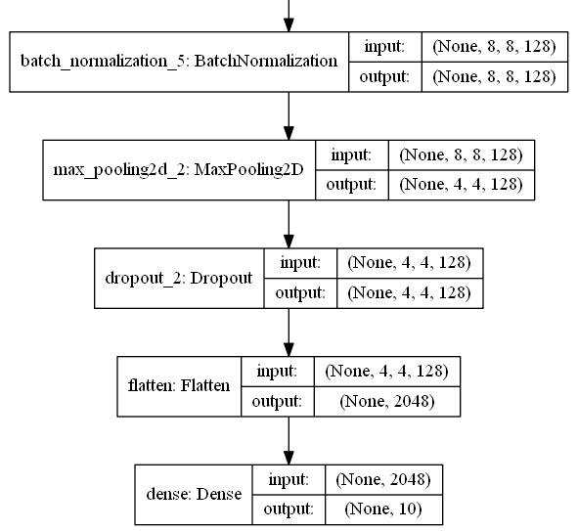
Final Results of predictions (Available classes are: [airplane, automobile, bird, cat, deer, dog, frog, horse, ship, truck])

Original Image | 256x256 resized image | 32x32 (Level 3) pyramid image of 256x256 | Class Probabilities | Maximal Class Probability
   |  |  | [  7.0537409e-11  4.7682043e-15  0.0000000e+00  1.1182911e-14  1.4756171e-30  8.3045746e-14  0.0000000e+00  2.1457900e-15  2.8690471e-26  1.0000000e+00] | truck
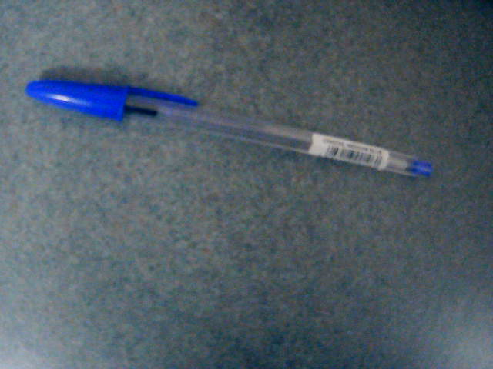  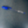 |  |  | [  9.9989712e-01  1.6290996e-19  0.0000000e+00  9.3706314e-13  0.0000000e+00  1.0286330e-04  0.0000000e+00  4.5009605e-09  1.7185493e-24  5.7645524e-09  ] | airplane
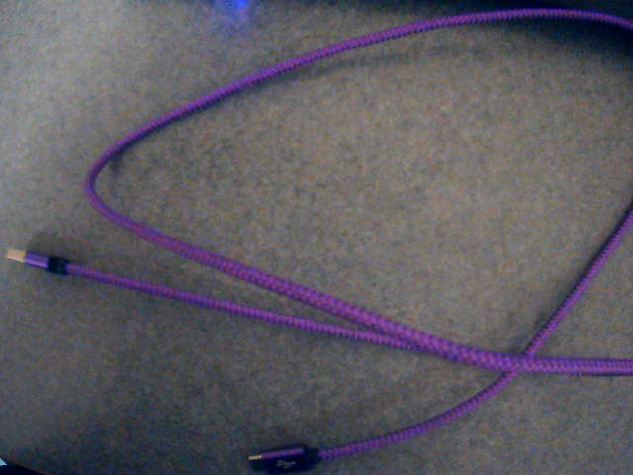   | 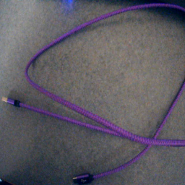 |  | [  5.2923439e-17  2.1673228e-24  3.0575725e-37  5.4800838e-01  2.4888288e-19  4.3766928e-09  0.0000000e+00  4.5199162e-01  1.3900030e-23  1.0630394e-09  ] | cat
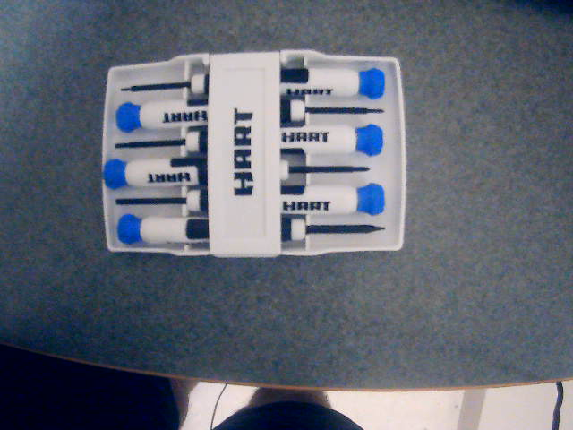  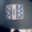 | 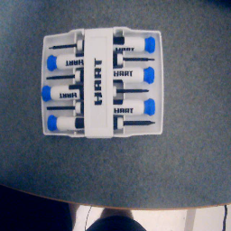 |  | [  6.9309461e-24  9.9963772e-01  0.0000000e+00  3.6223623e-04  0.0000000e+00  1.0139613e-11  0.0000000e+00  0.0000000e+00  4.1359097e-17  3.1870651e-21  ] | automobile

